B&D Staffingsolutions
B&D Staffing Solutions LLC
Application For Employment

Please print or type. The
application must be fully
completed to be
considered. Please
complete each section,
even if you attach a
resume.
We are an Equal
Opportunity Employer and
committed to excellence
through diversity.

Personal Information
Name
Address | City | State | Zip
Phone number | Email address
Are you legally eligible to work in the US?  Yes No | Are you a veteran?  Yes No
If selected for employment are you willing to submit to a background check?
Yes No
Position
Position you are applying for  APRN RN LPN NA TECH OTHER_______  Area of specialty: ICU Medsurg. Telemetry. Rehab/Long Term Care. Dialysis | Available start date |  | FT PT
BLS___ ACLS____ PALS____

Licensed Number:_______________State:______
List all states/Territories you have ever Registered as a RN/APRN/NA_______

Registration Number:__________Expiration Date:_______

Do you have pending or have you ever had any registration practice revoked suspended restricted probation or voluntary relinquished Yes No if yes explain:_____________________

Employment History
Employer (1) | Job title |  | Dates employed
Work phone | Starting pay rate |  | Ending pay rate
Address | City | State | Zip
Employer (2) | Job title |  | Dates employed
Work phone | Starting pay rate |  | Ending pay rate
Address | City | State | Zip
Employer (3) | Job title |  | Dates employed
Work phone | Starting pay rate |  | Ending pay rate
Address | City | State | Zip
Employer (4) | Job Title |  | Dates employed
Work phone | Starting pay rate |  | Ending pay rate
Address | City | State | Zip
Employer (5) | Job title |  | Dates employed
Work phone | Starting pay rate |  | Ending pay rate
Address | City | State | Zip
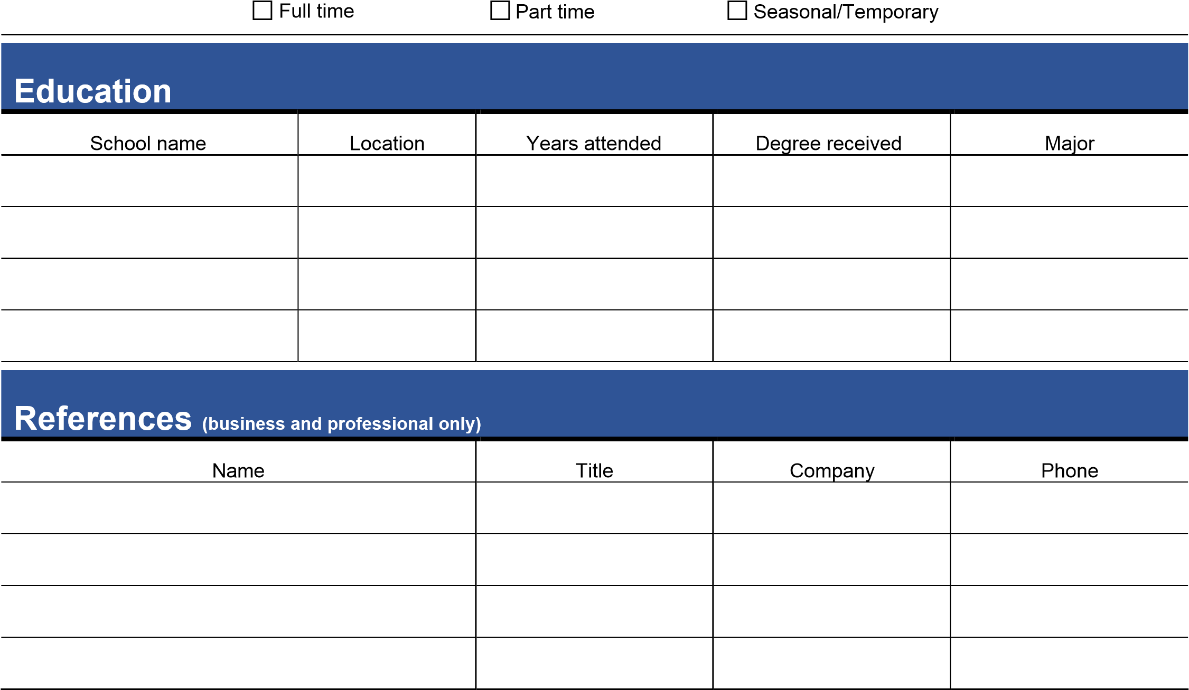
Signature Disclaimer
I certify that my answers are true and complete to the best of my knowledge.
If this application leads to employment, I understand that false or misleading information in my application or interview may result in my employment being terminated.
Name (please print) | Signature
Date
AUTHORIZATION FOR RELEASE OF INFORMATION
In order for B&D Staffing Solutions LLC to assess and verify my educational background, professional qualifications and suitability for employment: I Authorize B&D Staffing Solutions to make inquiries concerning such information about me to my previous employer(s), current employer, educational institutions, State licensing boards, other professional organizations and/or persons, agencies, organizations or institutions listed by me as references, and to any other appropriate sources to whom B&D Staffing Solutions may be referred by those contacted or deemed appropriate;
Authorize release of such information and copies of related records and/or documents to B&D Staffing Solutions LLC.
Release from liability all those who provide information to B&D Staffing Solutions LLC in good faith and without malice in response to such inquiries; and
Authorize B&D Staffing Solutions LLC to disclose to such persons, employers, institutions, boards or agencies identifying and other information about me to enable B&D Staffing Solutions to make such inquiries.

Name________________ Signature_____________________

